**Assignment No.2**

1. **Create a new branch called feature/expense-tracker.**

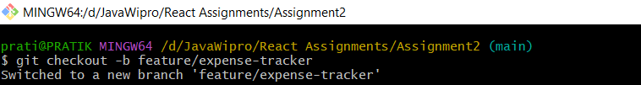

1. Modify the README.md to include a &quot;Features in Development&quot; section.

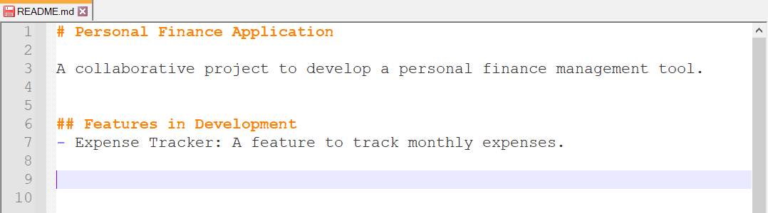

1. **Simulate an unfinished change by adding a placeholder section to README.md.**

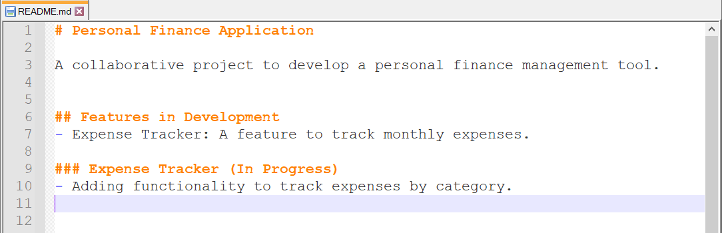

1. **Stash the changes using Git stash.**

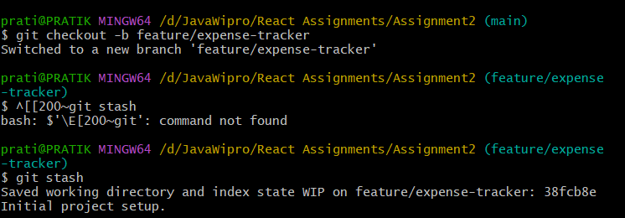

1. **Switch to the main branch and create a new branch bugfix/login-error.**

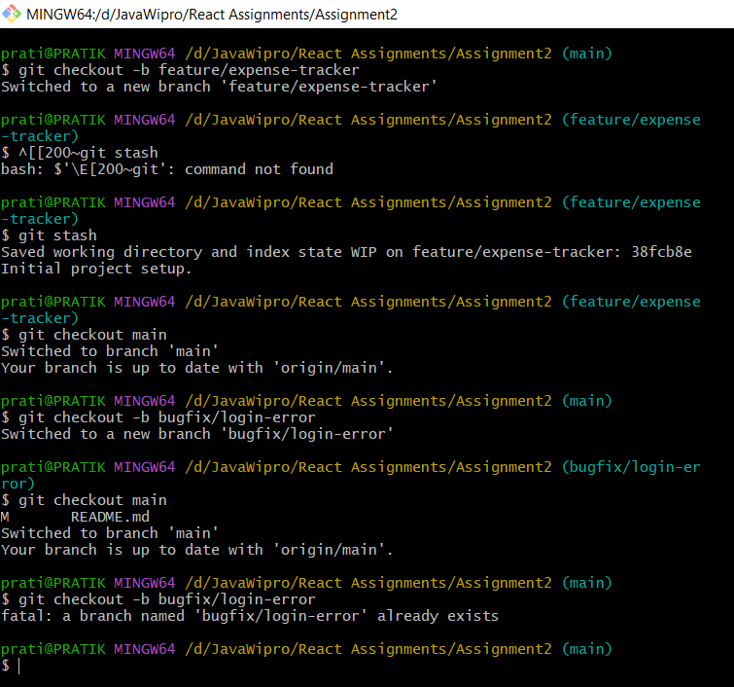

1. **Fix the login error by adding a simulated commit.**

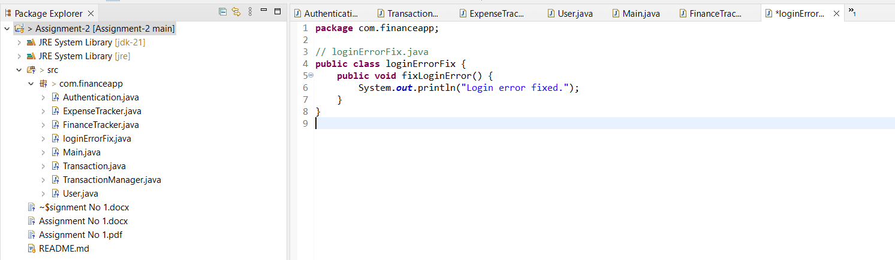

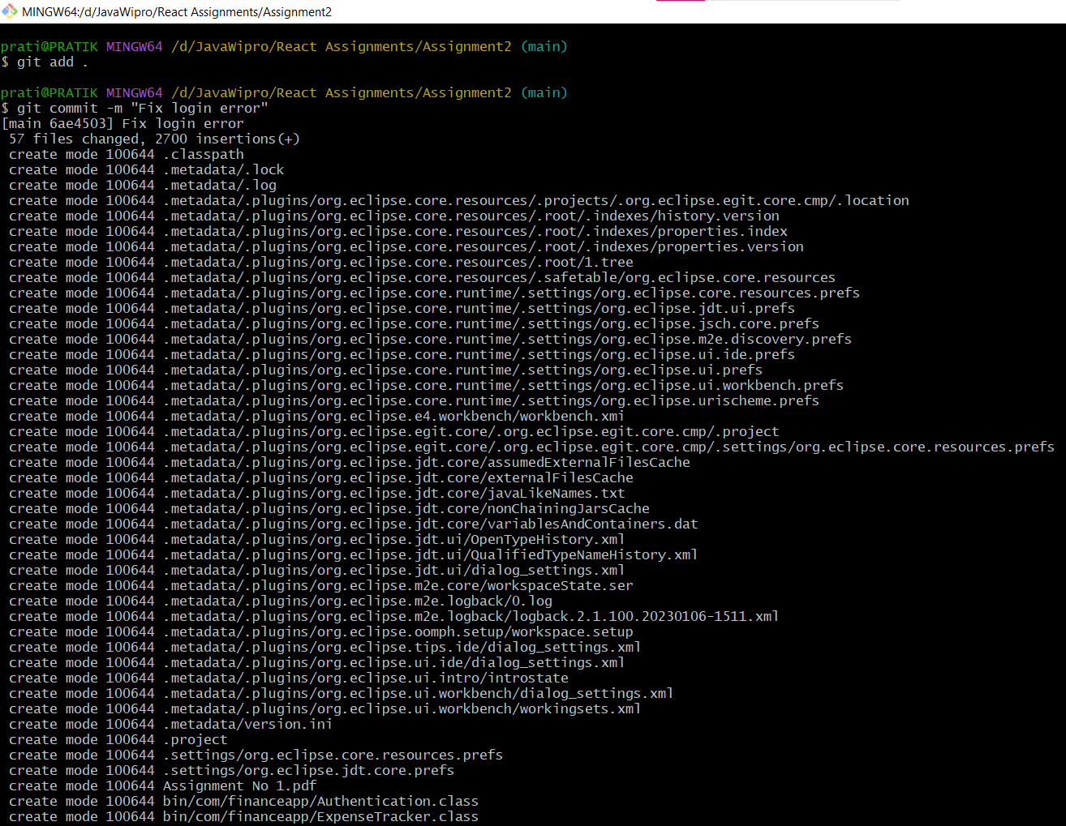

1. **Push both the bugfix and feature branches to GitHub.**

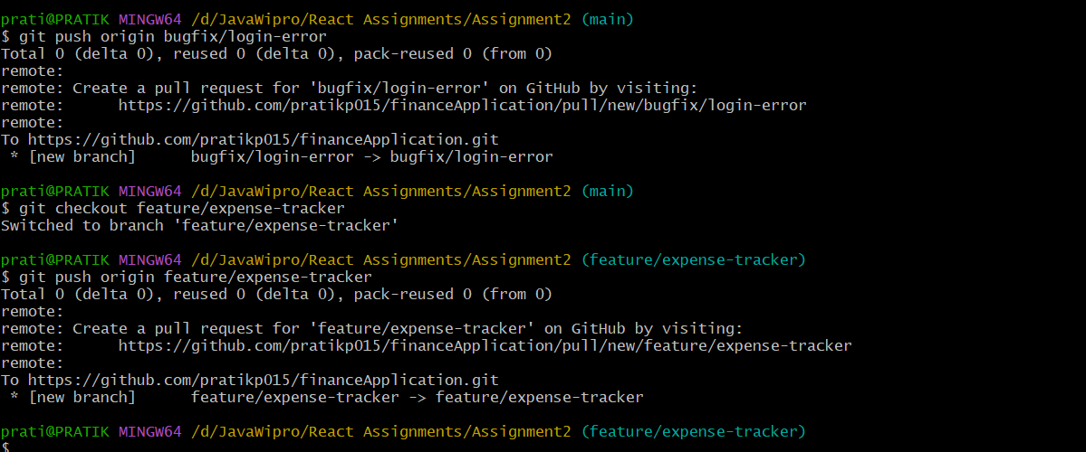

1. **Open a pull request for both branches.**

